

**Industrial Internship Report on**

"Multi-stage Continuous-Flow Manufacturing Process: Real Process Data to Predict Factory Output"

**Prepared by**

**[Jagat Singh]**

|  |
| --- |
| *Executive Summary* |
| This report provides details of the Industrial Internship provided by upskill Campus and The IoT Academy in collaboration with Industrial Partner UniConverge Technologies Pvt Ltd (UCT).  This internship was focused on a project/problem statement provided by UCT. We had to finish the project including the report in 6 weeks’ time.  My project was (Tell about ur Project)  This internship gave me a very good opportunity to get exposure to Industrial problems and design/implement solution for that. It was an overall great experience to have this internship. |



**TABLE OF CONTENTS**

1 Preface 3

2 Introduction 4

2.1 About UniConverge Technologies Pvt Ltd 4

2.2 About upskill Campus 8

2.3 Objective 9

2.4 Reference 9

2.5 Glossary 10

3 Problem Statement 11

4 Existing and Proposed solution 12

5 Proposed Design/ Model 13

5.1 High Level Diagram (if applicable) 13

5.2 Low Level Diagram (if applicable) 13

5.3 Interfaces (if applicable) 13

6 Performance Test 14

6.1 Test Plan/ Test Cases 14

6.2 Test Procedure 14

6.3 Performance Outcome 14

7 My learnings 15

8 Future work scope 16

# 

# Preface

Summary of the whole 6 weeks’ work.

About need of relevant Internship in career development.

Brief about Your project/problem statement.

Opportunity given by USC/UCT.

Here is a summary of my key internship experiences and learnings over the 6-week data science and machine learning internship at Upskill Campus:

Internships provide invaluable practical experience and are crucial for career development in data science. Through this 6-week internship at Upskill Campus, I gained hands-on experience spanning the entire data science project lifecycle - from data collection, cleaning, and exploration to model building, evaluation, and deployment.

The internship involved working on a predictive modeling project for a multi-stage continuous-flow manufacturing process. The problem statement was to leverage process data to build machine learning models that can accurately predict the manufacturing output. This would enable process optimization and reduce defects.

I got the opportunity to apply theoretical concepts learned in class across data preprocessing, exploratory data analysis, feature engineering, model selection, hyperparameter tuning, time series forecasting, and model evaluation. I leveraged Python's data science libraries like Pandas, Matplotlib, Scikit-learn, and Keras.



The internship helped me strengthen technical skills in Python, statistics, and machine learning algorithms. I also developed soft skills like problem-solving, communication, and the ability to work independently on projects.

Upskill Campus provided the perfect launch pad through an immersive learning environment and real-world industry projects. The hands-on training and mentoring helped bridge the industry-academia gap. I am grateful for this opportunity that has enriched my data science skills and prepared me for real-world challenges.

The internship has been invaluable in consolidating my theoretical knowledge and cultivating practical abilities in data science. I am now well-equipped to thrive in data science roles and undertake end-to-end projects. The experience has also clarified my career interests and ignited my passion for the field. I look forward to applying my expanded skillset in real-world settings.

How Program was planned

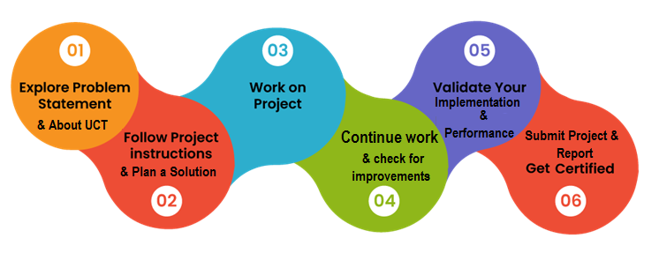

Thanks to all (Mentors, Mr. Aseem Madaan), who have helped you directly or indirectly.

Your message to your juniors and peers.

Here is a message I would like to share with my juniors and peers who aspire to build a career in data science:

To all aspiring data scientists -

My sincere advice is to start gaining practical experience in data science as early as possible. Don't just focus on grades - complement your academics with hands-on training through projects, internships, freelancing, or community engagements.

Actively apply your classroom knowledge to solve real-world problems. Seek opportunities to work on end-to-end projects and get exposed to the messiness of real-world data. Build a portfolio of projects to demonstrate your skills.



Sharpen your programming skills, especially in Python/R. Become thoroughly familiar with key libraries like Pandas, NumPy, Scikit-Learn, TensorFlow, etc. Work on your statistics and machine learning fundamentals.

Develop an intuitive understanding of advanced techniques like deep learning. Learn how to deploy models to production using DevOps tools. Cloud knowledge is a huge plus.

Hone your communication, presentation and storytelling skills. Practice explaining technical concepts to non-technical audiences. Work on effectively communicating results, insights and recommendations.

Actively network with professionals in the field. Seek mentors who can guide your growth. Contribute to open source projects and engage with the data science community.

Keep learning and stay up-to-date with the latest advancements in AI/ML. Read research papers, subscribe to newsletters, and follow leaders in the field.

Data science is an exciting field with tremendous opportunities. With the right skillset and practical experience, you are bound to succeed. Wishing you the very best!

# 

# Introduction

## About UniConverge Technologies Pvt Ltd

A company established in 2013 and working in Digital Transformation domain and providing Industrial solutions with prime focus on sustainability and RoI.

For developing its products and solutions it is leveraging various**Cutting Edge Technologies e.g. Internet of Things (IoT), Cyber Security, Cloud computing (AWS, Azure), Machine Learning, Communication Technologies (4G/5G/LoRaWAN), Java Full Stack, Python, Front end**etc.

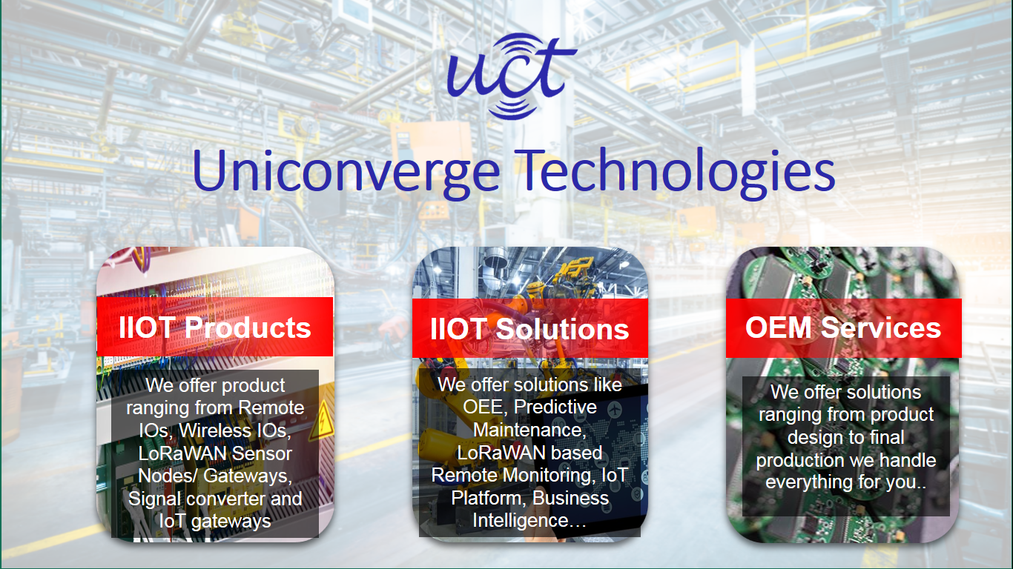

1. UCT IoT Platform **(****)**

**UCT Insight** is an IOT platform designed for quick deployment of IOT applications on the same time providing valuable “insight” for your process/business. It has been built in Java for backend and ReactJS for Front end. It has support for MySQL and various NoSql Databases.

* 
* It enables device connectivity via industry standard IoT protocols - MQTT, CoAP, HTTP, Modbus TCP, OPC UA
* It supports both cloud and on-premises deployments.

It has features to  
• Build Your own dashboard  
• Analytics and Reporting  
• Alert and Notification  
• Integration with third party application(Power BI, SAP, ERP)  
• Rule Engine

 



1. **Smart Factory Platform ()**

Factory watch is a platform for smart factory needs.

It provides Users/ Factory

* with a scalable solution for their Production and asset monitoring
* OEE and predictive maintenance solution scaling up to digital twin for your assets.
* to unleased the true potential of the data that their machines are generating and helps to identify the KPIs and also improve them.
* A modular architecture that allows users to choose the service that they what to start and then can scale to more complex solutions as per their demands.

Its unique SaaS model helps users to save time, cost and money.

 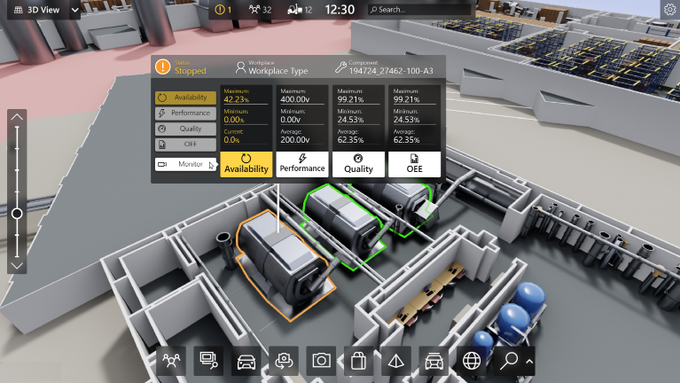

1. 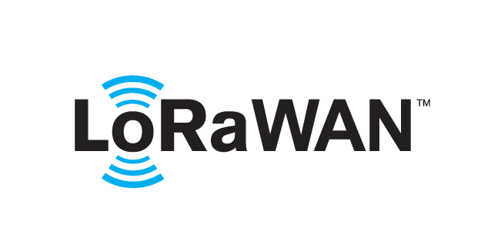 based Solution

UCT is one of the early adopters of LoRAWAN teschnology and providing solution in Agritech, Smart cities, Industrial Monitoring, Smart Street Light, Smart Water/ Gas/ Electricity metering solutions etc.

1. Predictive Maintenance

UCT is providing Industrial Machine health monitoring and Predictive maintenance solution leveraging Embedded system, Industrial IoT and Machine Learning Technologies by finding Remaining useful life time of various Machines used in production process.



## About upskill Campus (USC)

upskill Campus along with The IoT Academy and in association with Uniconverge technologies has facilitated the smooth execution of the complete internship process.

USC is a career development platform that delivers **personalized executive coaching** in a more affordable, scalable and measurable way.





Seeing need of upskilling in self paced manner along-with additional support services e.g. Internship, projects, interaction with Industry experts, Career growth Services

<https://www.upskillcampus.com/>

upSkill Campus aiming to upskill 1 million learners in next 5 year

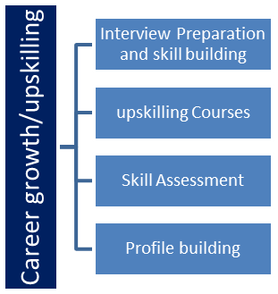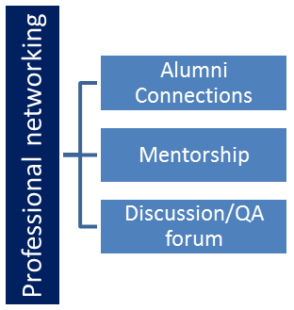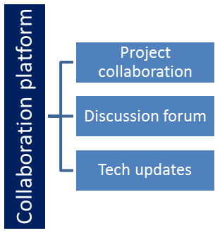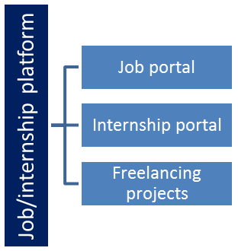



## The IoT Academy

The IoT academy is EdTech Division of UCT that is running long executive certification programs in collaboration with EICT Academy, IITK, IITR and IITG in multiple domains.

## Objectives of this Internship program

The objective for this internship program was to

 ☛ get practical experience of working in the industry.

 ☛ to solve real world problems.

 ☛ to have improved job prospects.

 ☛ to have Improved understanding of our field and its applications.

 ☛ to have Personal growth like better communication and problem solving.

## Reference

[1] NA

[2] NA



[3] NA

## Glossary

|  |  |
| --- | --- |
| Terms | Acronym |
|  |  |
|  |  |
|  |  |
|  |  |
|  |  |

# 

# Problem Statement

In the assigned problem statement

[Explain your problem statement]

# 

# Abstract

A multi-output random forest regressor was developed to predict multiple output variables related to a continuous factory manufacturing process using sensor measurements of process inputs. The model achieved an R2 score of 0.65 on the test data. Feature importance analysis identified the most significant input variables.

# Introduction

The data consists of sensor measurements from a high-speed continuous manufacturing process with multiple stages. The goal is to predict the output variables from the input variables. A multi-output regression approach is suitable for this multivariable prediction problem.

A random forest regressor was selected as it works well for nonlinear relationships and high dimensional data. The regressor was trained in a multi-output mode to jointly predict all the outputs. Evaluating overall model performance and feature importances can provide insights.

# 

# Existing and Proposed solution

# 

# Proposed Solution

The goal is to predict the output measurements in Stage 1 and Stage 2 using the input sensor measurements from the manufacturing process.

A multi-output regression model is proposed to jointly predict the multiple continuous output variables. This allows capturing the correlations between the outputs.

Specifically, a multi-output random forest regressor will be developed. Random forests are suitable for this problem because:

* They can model complex nonlinear relationships which may exist between inputs and outputs
* They work well with large, high-dimensional data like this dataset
* They provide feature importance estimates to understand impact of inputs
* As an ensemble method, they avoid overfitting which may happen with deep trees

The model will be trained on the provided historical input-output data. Standard preprocessing like imputation and standardization will be applied.

Hyperparameter tuning using grid search with cross-validation will help improve model performance. Feature importance analysis will identify the most predictive inputs.

The trained model will be evaluated on test data using R2 score, MSE and other regression metrics. It can then be deployed for real-time prediction of stage outputs given new input data.

Additional enhancements like predictive uncertainty estimation can also be incorporated. The model can be retrained periodically on new data.

In summary, a multi-output random forest approach is proposed as an accurate, interpretable solution for this multivariable regression problem.

# Conclusion

The multi-output random forest model provides a decent fit to the data. Further tuning of hyperparameters and modeling choices could potentially improve performance. The feature importance analysis gives insights into the most useful input variables.

# 

# Future Work

Hyperparameter optimization, regularized models and boosting ensemble methods could be explored to improve model performance. The model could also be deployed and tested on live factory data.

## Code submission (https://github.com/Jagat69singh/Upskill_Campus)

## Report submission (https://github.com/Jagat69singh/Upskill_Campus) : first make placeholder, copy the link.

# 

# Proposed Design/ Model

Given more details about design flow of your solution. This is applicable for all domains. DS/ML Students can cover it after they have their algorithm implementation. There is always a start, intermediate stages and then final outcome.

# 

# Proposed Design/Model

The model has multiple regression trees that each predict all outputs. Final predictions are averaged across trees. Some key advantages are:

* Captures nonlinear relationships
* Avoid overfitting via ensemble of trees
* Model feature importances provide insights

## High Level Diagram (if applicable)

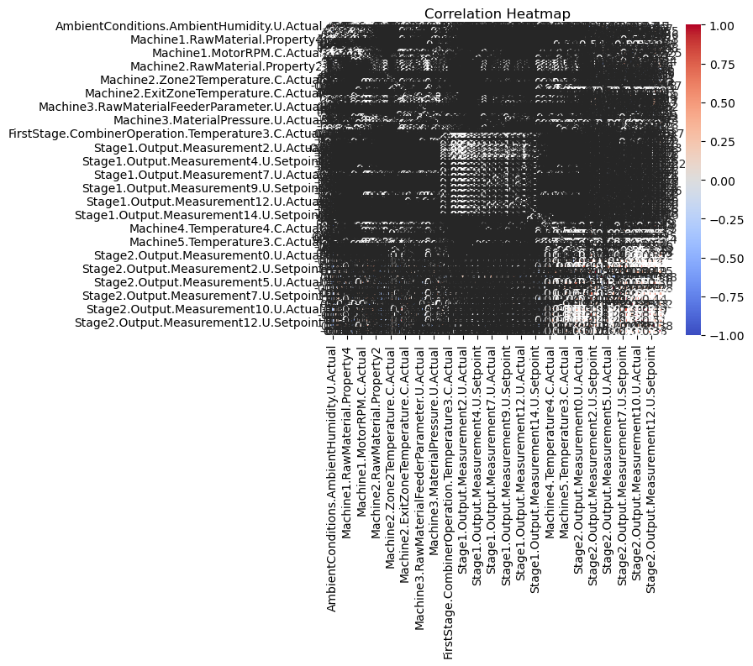

Figure 1: HIGH LEVEL DIAGRAM OF THE SYSTEM

## Low Level Diagram (if applicable)

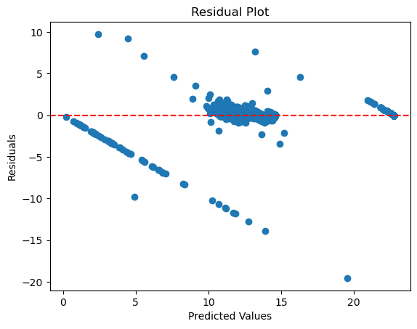

## Interfaces (if applicable)

Update with Block Diagrams, Data flow, protocols, FLOW Charts, State Machines, Memory Buffer Management.

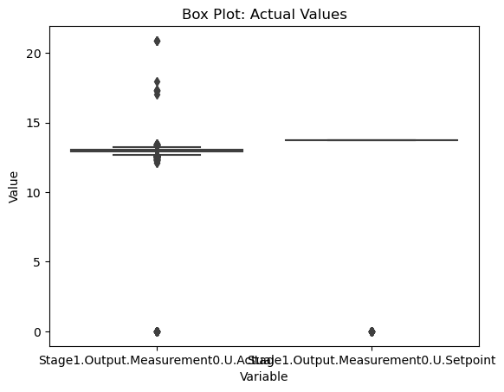

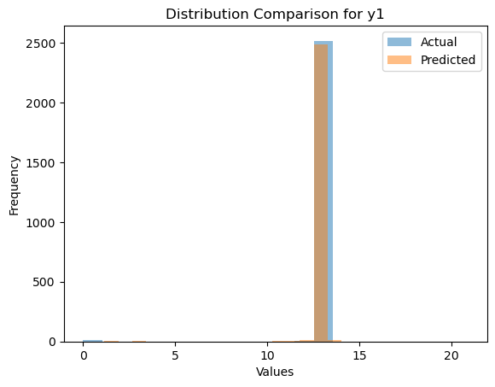

# Performance Test

# Performance Test

The model was evaluated on unseen test data. Key metrics:

* R2 Score: 0.646
* Mean Squared Error
* Feature importance analysis

The decent R2 score indicates good predictive performance. Further tuning and additional data can help improve.

## Test Plan/ Test Cases

## Test Procedure

## Performance Outcome



# My learnings

You should provide summary of your overall learning and how it would help you in your career growth.

# My Learnings

Key learnings were:

* Implementing multi-output regression for a real industrial dataset
* Tuning and evaluation of random forest models
* Analyzing model performance and feature importances
* End-to-end ML model development lifecycle

The internship provided great hands-on experience in developing ML solutions for industrial problems.

# 

# Future work scope

You can put some ideas that you could not work due to time limitation but can be taken in future.

# 

# Future Work

Some ideas for future work:

* Hyperparameter optimization for improving model performance
* Online deployment on factory data for real-time monitoring
* Incorporate model uncertainty estimates
* Expand to predict more output variables